DS_LAB_07
Sir Shafique Rehman
Muhammad Fazeel
24K-0919

Task # 1:
#include <bits/stdc++.h>
using namespace std;

class Student {
public:
int score;
string name;
Student() {}
Student(string s, int sc) {
score = sc;
name = s;
}
};

class Node {
public:
Student student;
Node* next;
Node(Student s) {
student = s;
next = NULL;
}
};

class LinkedList {
public:
Node* head;
Node *tail;

LinkedList() {
head = NULL;
}
void insertAtHead(Student val) {
Node* newNode = new Node(val);
newNode->next = head;
head = newNode;
}
void print() {
Node* temp = head;
while (temp != NULL) {
cout << temp->student.name << " " << temp->student.score << endl;
temp = temp->next;
}
}

void deleteAtPosition(int pos) {
if (head == NULL) return;
if (pos == 0) {
Node* temp = head;
head = head->next;
delete temp;
return;
}

Node* current = head;
for (int i = 0; current != NULL && i < pos - 1; i++) {
current = current->next;
}

if (current == NULL || current->next == NULL) {
return;
}
Node* temp = current->next;
current->next = temp->next;
delete temp;
}

int size() {
int count = 0;
Node* temp = head;
while (temp != NULL) {
count++;
temp = temp->next;
}
return count;
}
};

int getMax(Node* temp) {
int maxi = 0;
while (temp != NULL) {
if (temp->student.score > maxi) {
maxi = temp->student.score;
}
temp = temp->next;
}
return maxi;
}

void countSort(LinkedList* list, int exp) {
int size = list->size();
int count[10] = {0};
Node* current = list->head;

while (current != NULL) {
int digit = (current->student.score / exp) % 10;
count[digit]++;
current = current->next;
}

for (int i = 1; i < 10; i++) {
count[i] += count[i-1];
}

Student* output = new Student[size];
current = list->head;
for (int i = size - 1; i >= 0; i--) {
int digit = (current->student.score / exp) % 10;
output[count[digit] - 1] = current->student;
count[digit]--;
current = current->next;
}

current = list->head;
int i = 0;
while (current != NULL) {
current->student = output[i++];
current = current->next;
}
delete[] output;
}

void RadixSort(LinkedList* list) {
int maxi = getMax(list->head);
for (int exp = 1; maxi / exp > 0; exp *= 10) {
countSort(list, exp);
}
}

int binarySearch(Student arr[], int n, string name, int score) {
int low = 0, high = n - 1;
while (low <= high) {
int mid = (low + high) / 2;
if (arr[mid].score == score && arr[mid].name == name){
return mid;
}
else if (arr[mid].score < score) {
low = mid + 1;
}
else {
high = mid - 1;
}
}
return -1;
}

void copyToArray(LinkedList& list, Student arr[]) {
Node* temp = list.head;
int i = 0;
while (temp != NULL) {
arr[i++] = temp->student;
temp = temp->next;
}
}

int main()
{
LinkedList list;
list.insertAtHead(Student("Sara", 70));
list.insertAtHead(Student("Sohail", 30));
list.insertAtHead(Student("Ahmed", 20));
list.insertAtHead(Student("Ayan", 90));
list.insertAtHead(Student("Zameer", 60));

cout << "\nBefore sorting:\n";
list.print();

RadixSort(&list);

cout << "\nAfter sorting:\n";
list.print();

int n = list.size();
Student* arr = new Student[n];
copyToArray(list, arr);

string name;
int score;
cout<<"\nEnter name of student to search: ";
cin>>name;
cout<<"Enter the score: ";
cin>>score;

int pos = binarySearch(arr, n, name, score);

if (pos != -1) {
cout<<"\nRecord found and deleted.\n";
list.deleteAtPosition(pos);
}
else
{
cout << "\nRecord not found.\n";
}

cout << "\nUpdated List:\n";
list.print();

delete[] arr;
return 0;

}

Output:
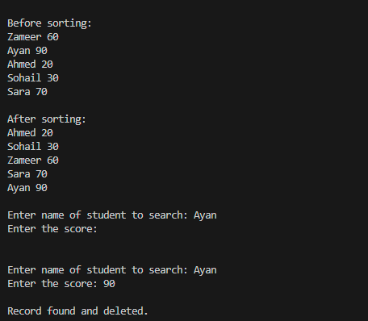
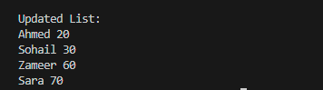

Task # 2:

#include <iostream>
using namespace std;

int getMax(int a[], int n) {
int max = a[0];
for(int i = 1; i<n; i++) {
if(a[i] > max)
max = a[i];
}
return max;
}
void countingSort(int arr[], int n, int exp) {
int *output = new int[n];
int count[10] = {0};

for (int i = 0; i < n; i++)
count[(arr[i] / exp) % 10]++;

for (int i = 8; i >= 0; i--)
count[i] += count[i + 1];

for (int i = n - 1; i >= 0; i--) {
int digit = (arr[i] / exp) % 10;
output[count[digit] - 1] = arr[i];
count[digit]--;
}

for (int i = 0; i < n; i++)
arr[i] = output[i];

delete[] output;
}

void radixsort(int a[], int n) {
int max = getMax(a, n);

for (int place = 1; max / place > 0; place *= 10)
countingSort(a, n, place);
}

void printArray(int a[], int n) {
for (int i = 0; i < n; ++i) {
cout<<a[i]<<" ";
}
cout<<"\n";
}

int main() {
int a[] = {36, 987, 654, 2, 20, 99, 456, 555, 957, 3, 66};

int n = sizeof(a) / sizeof(a[0]);
cout<<"Before sorting array elements are - \n";

printArray(a,n);
radixsort(a, n);
cout<<"After applying Radix sort, the array elements are -\n";
printArray(a, n);
}

Output:
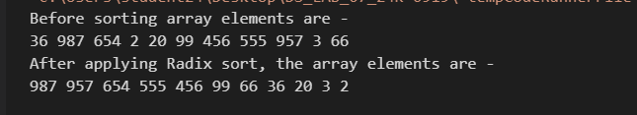

Task # 3:
#include <iostream>
using namespace std;

class Runner {
public:
string name;
int time;
Runner() {}
Runner(string n, int t) {
name = n;
time = t;
}
};
void merge(Runner arr[], int start, int mid, int end) {
int n1 = mid-start+1;
int n2 = end-mid;
Runner left[10],right[10];

for (int i = 0; i < n1; i++) {
left[i] = arr[start + i];
}

for (int j = 0; j < n2; j++) {
right[j] = arr[mid +1+j];
}

int i = 0, j = 0, k = start;
while (i < n1 && j < n2) {
if (left[i].time <= right[j].time) {
arr[k] = left[i];
i++;
}
else {
arr[k] = right[j];
j++;
}
k++;
}

while (i < n1) {
arr[k] = left[i];
i++;
k++;
}

while (j < n2) {
arr[k] = right[j];
j++;
k++;
}
}

void mergeSort(Runner arr[], int start, int end) {
if (start < end) {
int mid = (start + end) / 2;
mergeSort(arr, start, mid);
mergeSort(arr, mid + 1, end);
merge(arr, start, mid, end);
}
}

int main() {
int n = 10;
Runner runners[n] = {{"Ali", 320},{"Babar", 280},{"Moiz", 295},
{"Ayesha", 310},{"Ahmed", 270},{"Umar", 330},{"Fazeel", 285},
{"Aimna", 300},{"Bisma", 260},{"Usman", 340}
};

cout << "Original Runners:\n";
for (int i = 0; i < n; i++) {
cout << runners[i].name << " - " << runners[i].time << " seconds\n";
}

mergeSort(runners,0,n-1);

cout << "\n 5 Fastest Runners\n";
cout << "----------------------------------\n";
for (int i = 0; i < 5; i++) {
cout << i + 1 << ". " << runners[i].name << " - "<<runners[i].time << " seconds\n";
}

return 0;
}

Output:
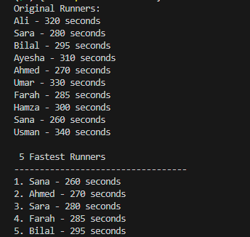
Task # 4:
#include <bits/stdc++.h>
using namespace std;

class Product {
public:
string name;
double price;
string description;
bool isavailable;
Product(string n, double p, string d, bool available) {
name = n;
price = p;
description = d;
isavailable = available;
}
void display() {
cout << "----------------------------------------\n";
cout << "Product Name : "<< name << endl;
cout << "Price : $" <<fixed<<setprecision(2) << price << endl;
cout << "Description : " << description << endl;
cout << "Available : "<<(isavailable ? "Yes" : "No")<< endl;
}
};

int partition(Product p[], int start, int end) {
double pivot = p[end].price;
int i = start-1;

for (int j = start; j < end; j++) {
if (p[j].price <= pivot) {
i++;
swap(p[i], p[j]);
}
}
swap(p[i+1], p[end]);

return i + 1;
}
void quick(Product p[], int start,int end) {
if (start < end) {
int part = partition(p, start, end);
quick(p, start, part - 1);
quick(p, part + 1, end);
}
}

int main() {
Product products[] = {
{"Product 1", 10.99, "This is product 1.", true},
{"Product 2", 5.99, "This is product 2.", false},
{"Product 3", 2.99, "This is product 3.", true}
};

int n = sizeof(products) / sizeof(products[0]);

cout << "========== BEFORE SORTING ==========\n";
for (int i = 0; i < n; i++)
products[i].display();

quick(products, 0, n - 1);

cout << "\n========== AFTER SORTING ==========\n";
for (int i = 0; i < n; i++)
products[i].display();

return 0;
}

Output:
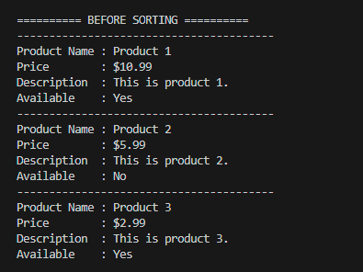
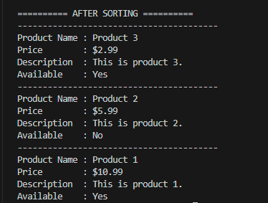

Task # 5:
#include <iostream>
using namespace std;

class Node {
public:
int data;
Node* next;
Node(int d) {
data = d;
next = NULL;
}
};

class LinkedList {
public:
Node* head;
Node* tail;

LinkedList() {
head = tail = NULL;
}
void insert(int val) {
Node* newNode = new Node(val);
if (head == NULL) {
head = tail = newNode;
return;
}
tail->next = newNode;
tail = newNode;
}
void display() {
Node* temp = head;

while (temp != NULL) {
cout << temp->data << " ";
temp = temp->next;
}
cout << endl;
}
};

void swap(Node* n1, Node* n2) {
int temp = n1->data;
n1->data = n2->data;
n2->data = temp;
}

Node* partition(Node* st, Node* end) {
int pivot = end->data;
Node* placeindex = st;
Node* temp = st;

while (temp != end) {
if (temp->data < pivot) {
swap(temp, placeindex);
placeindex = placeindex->next;
}
temp = temp->next;
}
swap(placeindex, end);
return placeindex;
}

void quickSort(Node* st, Node* end) {
if (st == NULL || st== end || end == NULL) {
return;
}

Node* pivotindex = partition(st, end);

Node* temp = st;
while (temp != NULL && temp->next != pivotindex) {
temp = temp->next;
}

if (temp != NULL)
quickSort(st, temp);

if (pivotindex != NULL && pivotindex->next != NULL)
quickSort(pivotindex->next, end);
}

int main() {
LinkedList list;

list.insert(1);
list.insert(2);
list.insert(5);
list.insert(0);
list.insert(52);
list.insert(33);
list.insert(15);

cout << "Original Linked List: ";
list.display();

quickSort(list.head, list.tail);

cout << "Sorted Linked List: ";
list.display();

return 0;
}

Output:

Task # 6:
#include<bits/stdc++.h>
using namespace std;

void merge(int a[], int beg, int mid, int end)
{
int i, j, k;
int n1 = mid - beg + 1;
int n2 = end - mid;
int LeftArray[n1], RightArray[n2];

for (int i = 0; i < n1; i++)
LeftArray[i] = a[beg + i];
for (int j = 0; j < n2; j++)
RightArray[j] = a[mid + 1 + j];
i = 0;
j = 0;
k = beg;
while (i < n1 && j < n2) {
if(LeftArray[i] <= RightArray[j]) {
a[k] = LeftArray[i];
i++;
}
else {
a[k] = RightArray[j];
j++;
}
k++;
}
while (i < n1) {
a[k] = LeftArray[i];
i++;
k++;
}

while (j < n2) {
a[k] = RightArray[j];
j++;
k++;
}
}

void mergeSort(int a[], int beg, int end)
{
if (beg < end)
{
int mid = (beg + end) / 2;
mergeSort(a, beg, mid);
mergeSort(a, mid + 1, end);
merge(a, beg, mid, end);
}
}

int main()
{
int arr1[10] = {3, 4, 5, 1, 8, 9, 10, 11, 13, 7};
int arr2[10] = {40, 23, 43, 11, 9, 7, 49, 33, 17, 21};

int arr3[20];
for (int i = 0; i < 10; i++)
{
arr3[i] = arr1[i];
}
int j = 10;
for (int i = 0; i < 10; i++)
{
arr3[j] = arr2[i];
j++;
}
cout << "\nBefore Sorting:\n";
for (int i = 0; i < 20; i++) {
cout << arr3[i] << " ";
}
cout << "\n";

mergeSort(arr3, 0, 19);

cout << "\nAfter Sorting :\n";

for (int i = 0; i < 20; i++) {
cout << arr3[i] << " ";
}
cout << "\n";

return 0;
}

Output:
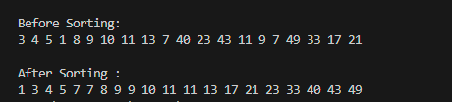

Task # 7:
#include <bits/stdc++.h>
using namespace std;

static int comparisons = 0;

int partitionStart(int arr[], int st, int end) {
int idx = st ;
int pivot = arr[st];

for (int i = st+1; i <= end; i++) {
comparisons++;
if (arr[i] <= pivot) {
idx++;
swap(arr[idx], arr[i]);
}
}
swap(arr[idx ], arr[st]);
return idx ;
}

int partitionEnd(int arr[], int st, int end) {
int idx = st - 1;
int pivot = arr[end];

for (int i = st; i < end; i++) {
comparisons++;
if (arr[i] <= pivot) {
idx++;
swap(arr[idx], arr[i]);
}
}
swap(arr[idx+1], arr[end]);
return idx + 1;
}

int partitionMiddle(int arr[], int st, int end) {
int mid = st + (end - st) / 2;
int pivot = arr[mid];

swap(arr[mid], arr[end]);
int i = st - 1;

for (int j = st; j < end; j++) {
comparisons++;
if (arr[j] <= pivot) {
i++;
swap(arr[i], arr[j]);
}
}
swap(arr[i + 1], arr[end]);
return i + 1;
}

int Findmedian(int a, int b, int c) {
if ((a > b) != (a > c)) return a;
else if ((b > a) != (b > c)) return b;
else return c;
}
int partitionMedian (int arr[], int st, int end) {
int mid = arr[(st + end) / 2];
int pivot = Findmedian (arr[st], arr[mid], arr[end]);

int pivotIndex;
if (pivot == arr[st]) pivotIndex = st;
else if (pivot == arr[mid]) pivotIndex = mid;
else pivotIndex = end;

swap(arr[pivotIndex], arr[end]);

int i = st - 1;
for (int j = st; j < end; j++) {
comparisons++;
if (arr[j] <= pivot) {
i++;
swap(arr[i], arr[j]);
}
}
swap(arr[i + 1], arr[end]);
return i + 1;
}

void quickSort(int arr[], int st, int end) {
if (st < end) {
int p = partitionMedian(arr, st, end);
quickSort(arr, st, p - 1);
quickSort(arr, p + 1, end);
}
}

int main() {

int arr[10] = {10,9,8,7,6,5,4,3,2,1};
int n = 10;
cout << "\n";
quickSort(arr, 0, n - 1);
for (int i = 0; i < n; i++) {
cout << arr[i] << " ";
}
cout << "\nTotal comparisons: " << comparisons;
return 0;
}

Output:
- Random Array

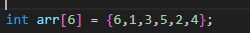

- First Element as Pivot:

- Last Element as Pivot:
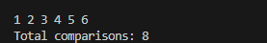

- Middle Element as Pivot:
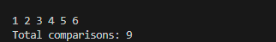
- Median Element as Pivot:
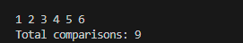

- Sorted Array:
- First Element as Pivot:
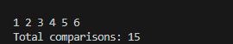
- Last Element as Pivot
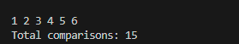

- Middle Element as Pivot
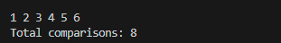

- Median Element as Pivot
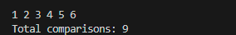

- Reverse Sorted:

- First Element as Pivot:
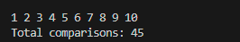
- Last Element as Pivot

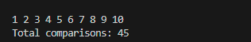
- Middle Element as Pivot
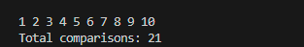

- Median Element as Pivot
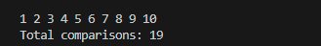

Observation:
In every dataset of Array (Middle Element and Median Element) has given the best result (minimum comparisons).

